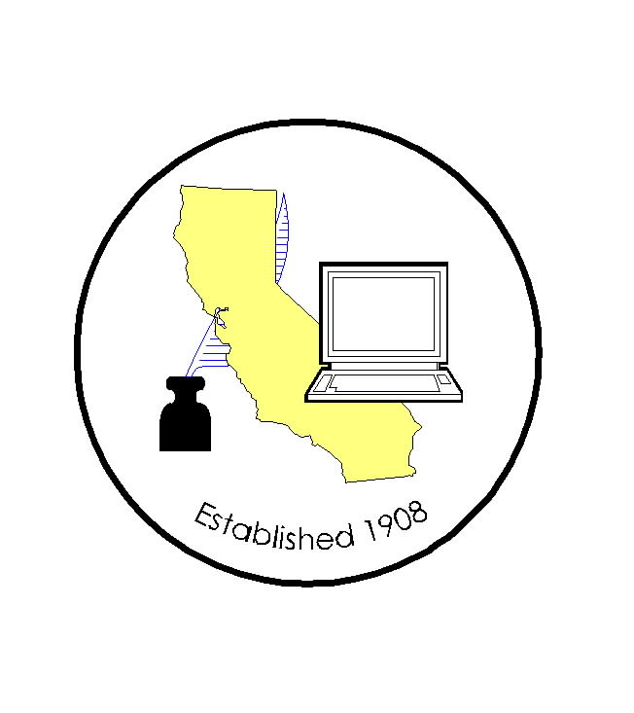
CALIFORNIA ASSOCIATION OF

CLERKS AND ELECTION OFFICIALS

PLEASE NOTE: REGISTRATION IS NOW BEING HANDLED BY
NEAL KELLEY, ORANGE COUNTY ROV*

DATE: September 14, 2007
TO: CACEO Members, Legislative Committee
FROM: *Neal Kelley, Orange County Registrar of Voters
SUBJECT: CACEO LEGISLATIVE COMMITTEE MEETING

DATE: FRIDAY, OCTOBER 12, 2007

TIME: 9:00 a.m. – 3:00 p.m.

LOCATION: Doubletree Hotel Phone: (800) 222-8733
2001 Point West (916) 929-8855
Sacramento, CA 95815 Rate: $110 sgl/dbl

SUBCOMMITTEES: Thursday, October 11, 2007
(contact Subcommittee Chairs for additional information)

REGISTRATION
(Registration deadline: October 5, 2007)

Name: ____________________________________________________

County/City: ____________________________________________________

Fee enclosed: Member: $55.00 (payment received by October 5th)
Auditor cutting check
$105.00 (payment received after October 5th)
Paid for year

Non-Member: $105.00 (payment received by October 5th)
$155.00 (payment received after October 5th)

Check payable to: California Association of Clerks and Election Officials

*Return to: Neal Kelley, Orange County Registrar of Voters
P. O. Box 11298
Santa Ana, CA 92711-1298
phone: (714) 567-7620
fax: (714) 567-7627
e-mail: Linda.Strickland@rov.ocgov.com

